* To create IAM user,group and attach direct policy to the IAM account.

01. Login the root account > service > security,identity and compliance > IAM.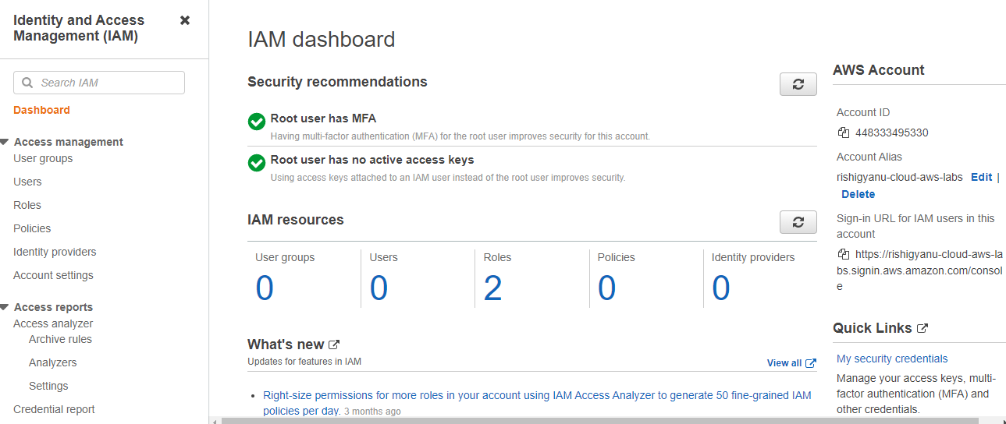

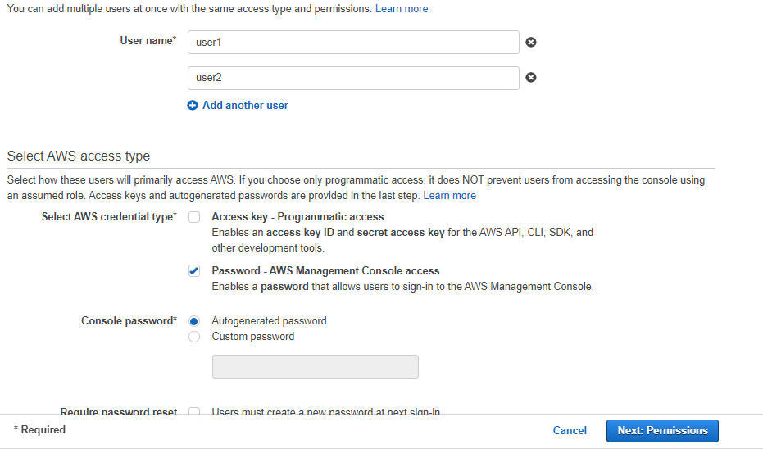

02. In this step we are going to create user.

We can create five user at a time and attach direct policy with the user but here we are creating two user at time.

1. User1
2. User2
3. AWS credential type - ‘password management console access’
4. Password console - auto generated.
5. Password reset - uncheck .

03.In this step we are going to attach the policy which is existing in AWS i select Amazon S3 Read Only Access. 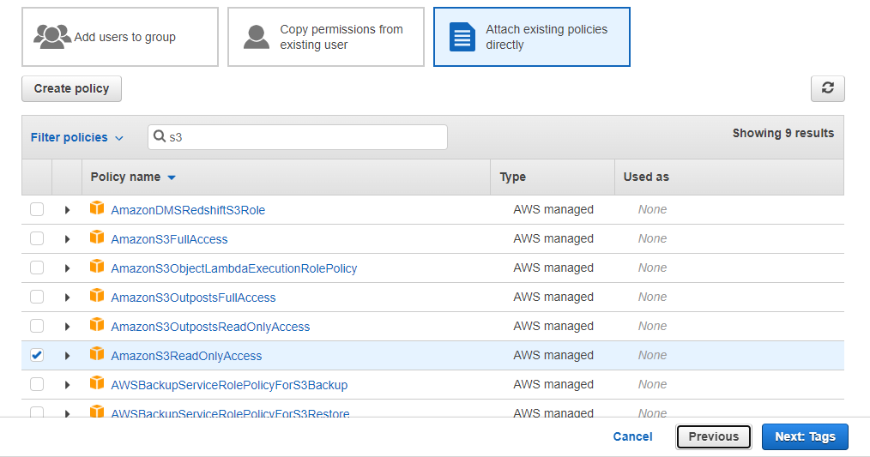

04.Tag is optional we can make it tag after.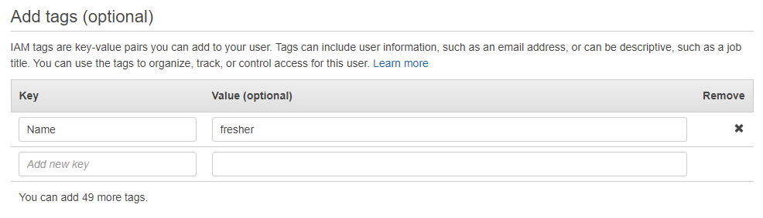

05.It show review of user which we are creating make it sure all thing right and click create users.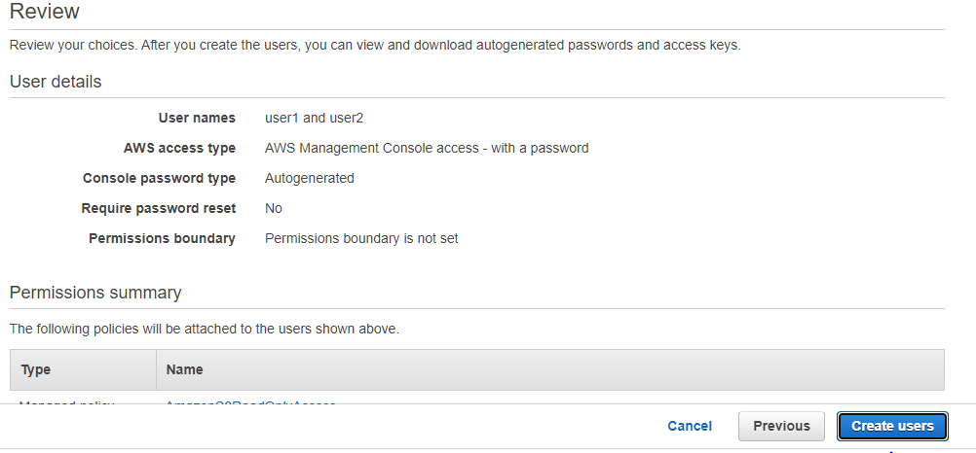

06.it successfully created user1 and user2.

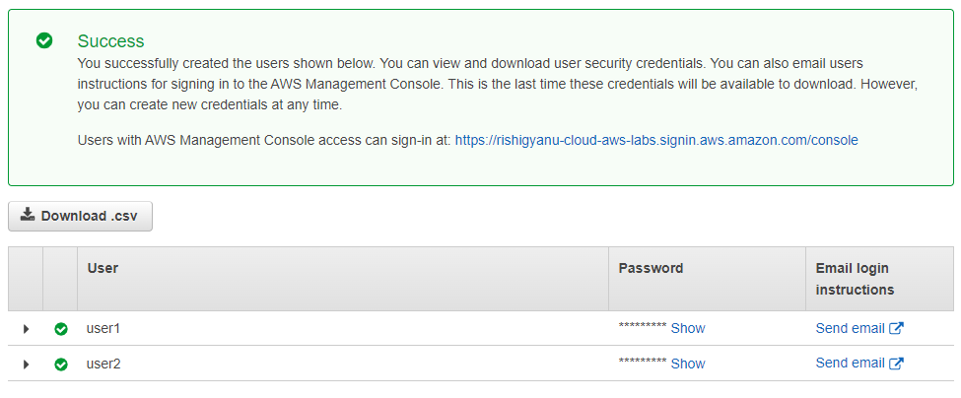

07.It show policy AmazonS3ReadOnlyAccess of user1 and same for user2

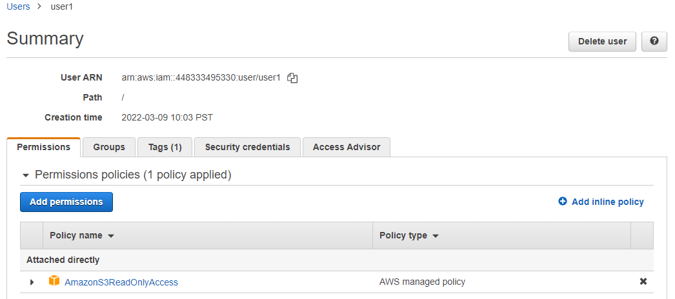

A.

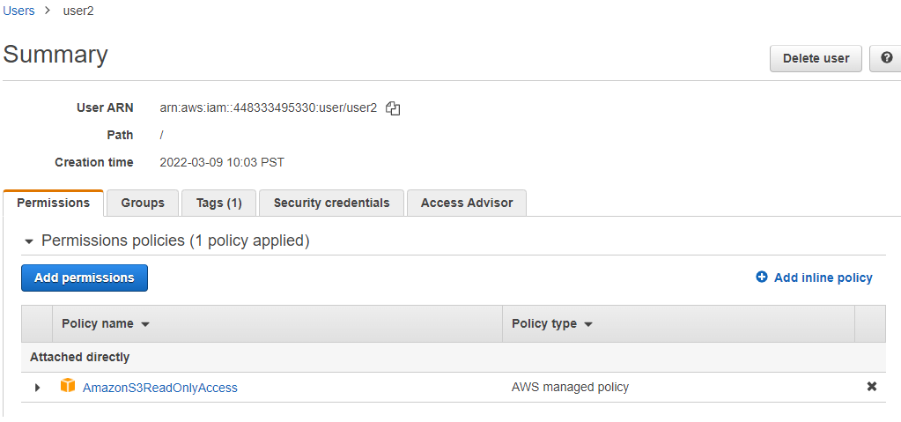

B.

08. For user2 we are going to add inline policy so as to user2 can make bucket and delete.

Inline policy > visual editor > choose sevice > search S3 > select S3 > add

write permission > select create buckt and delete bucket > resources > all

resources > click on create.

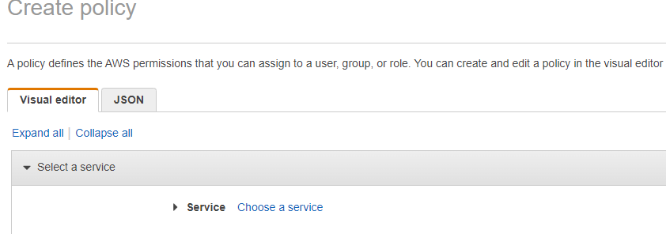

1



2

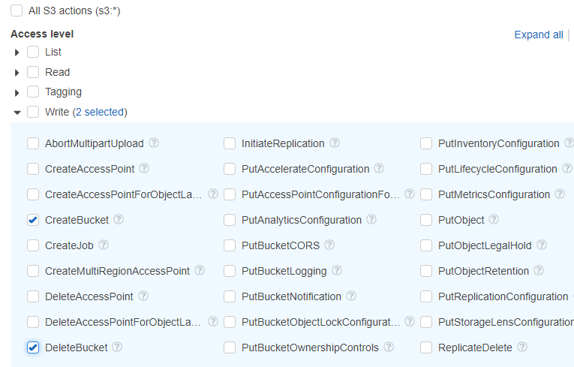

3

4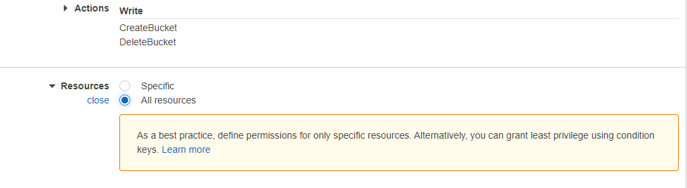

5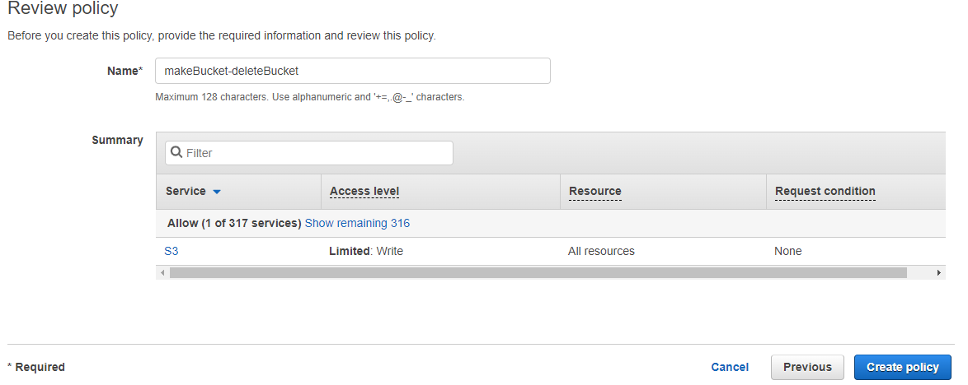

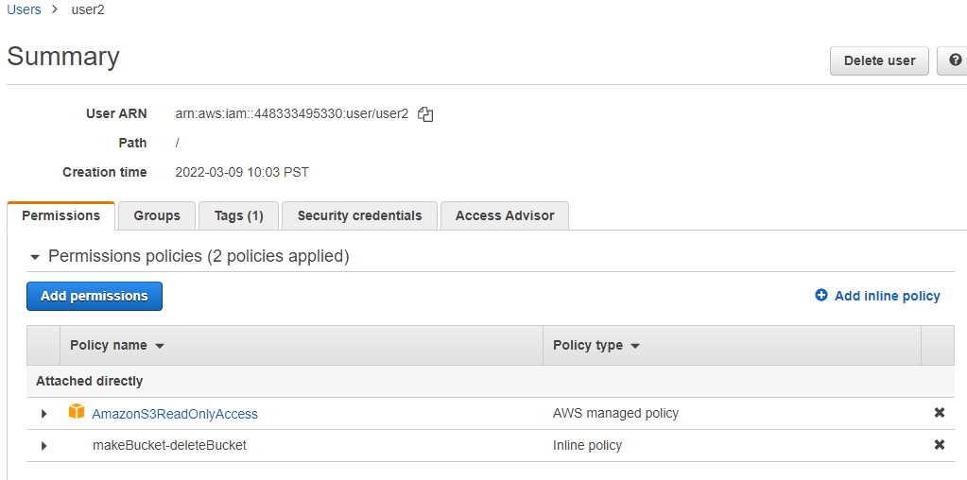

6

We can see here inline policy of make bucket and delete bucket added with user2 successfully.

09.in this step we are going to login iam user1 and user2 to check it perform well or not which we added with both user and user. We open new incognito window search url which given while creating user.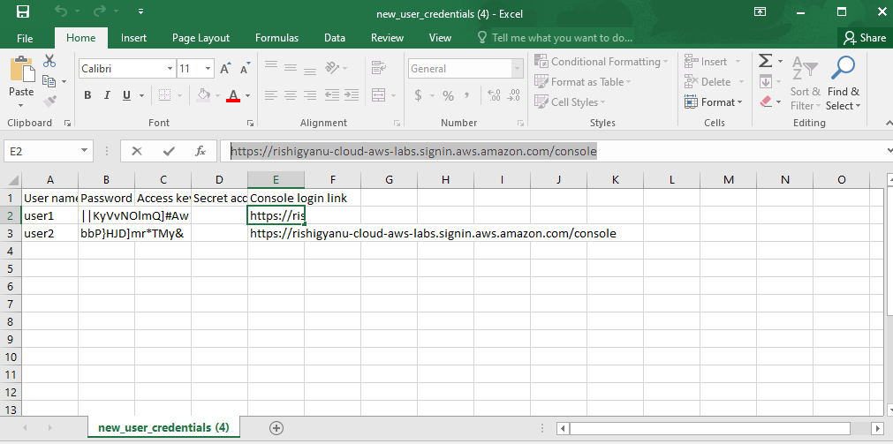

1

2

3

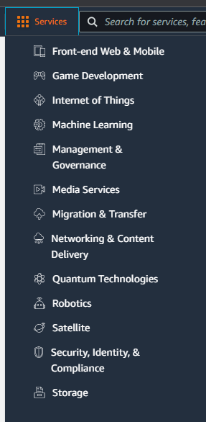

4

5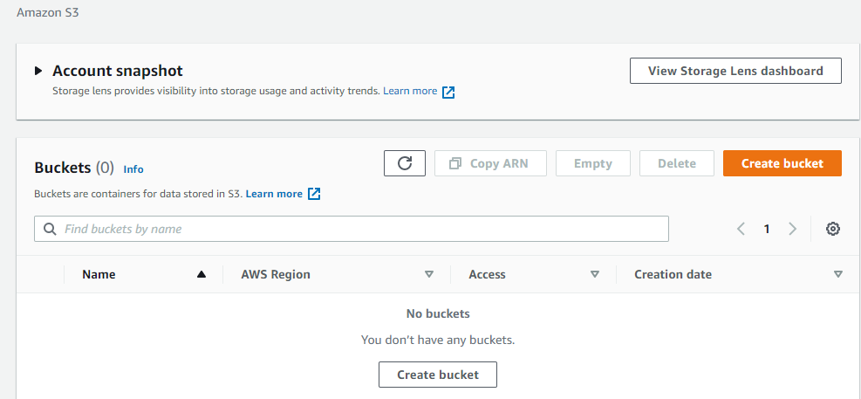

6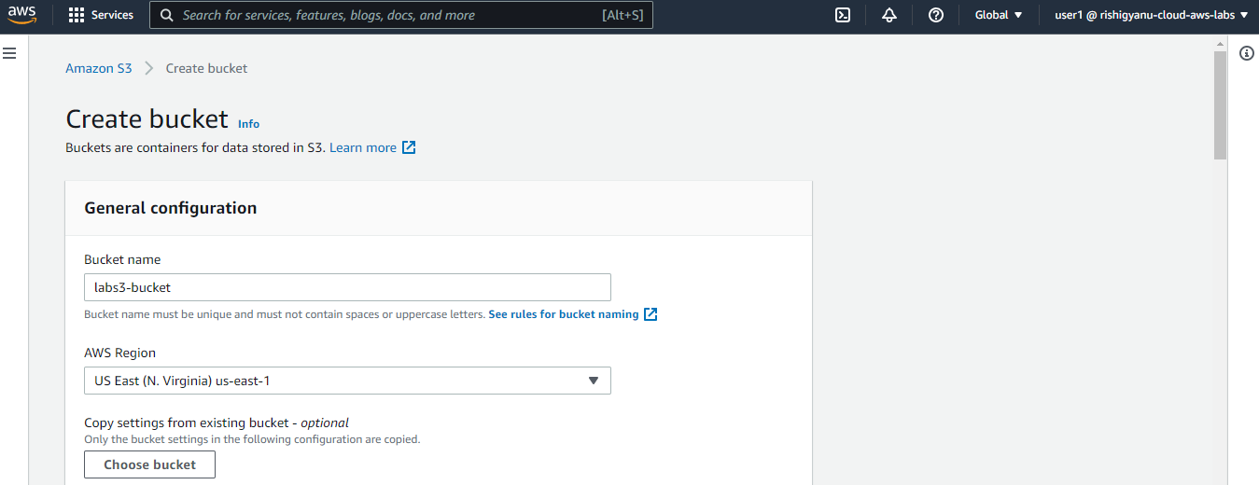

User1 can read all about S3 but can’t write in S3 because it has only read access permission if we try to do something it give error or access denied as shown in below.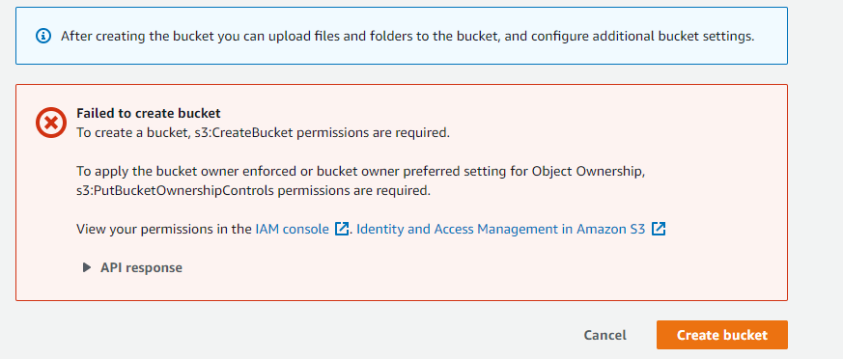

10.I this step we go for user2 it can read and write about S3 .

A.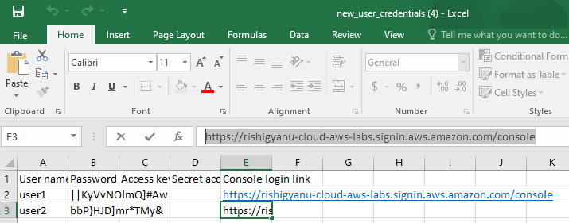

B. 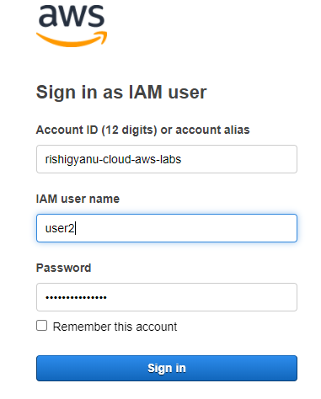

C. 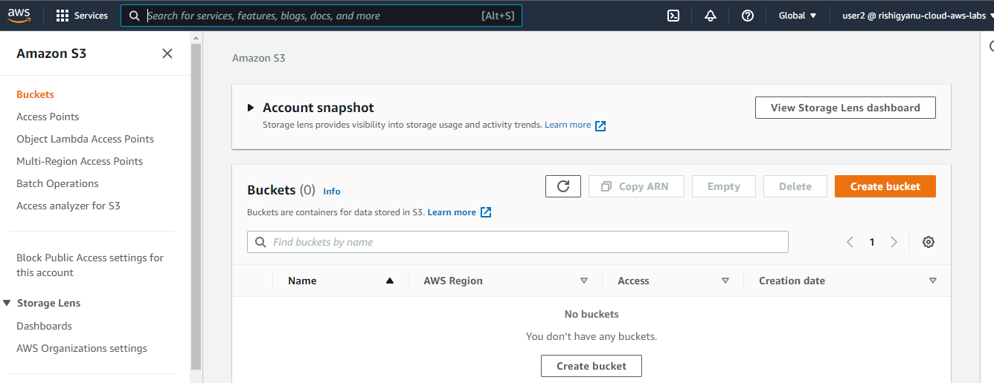

D. 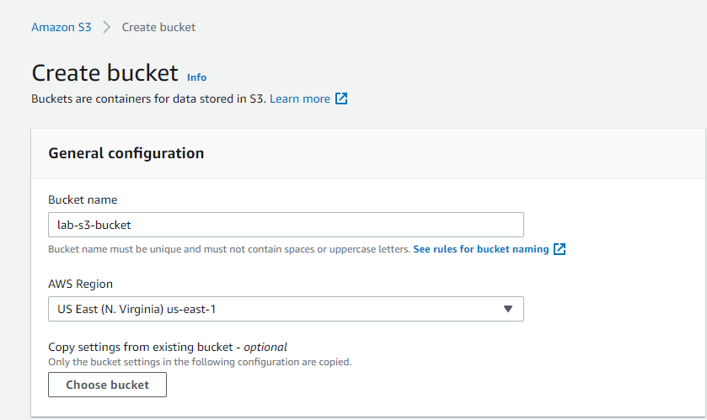

E.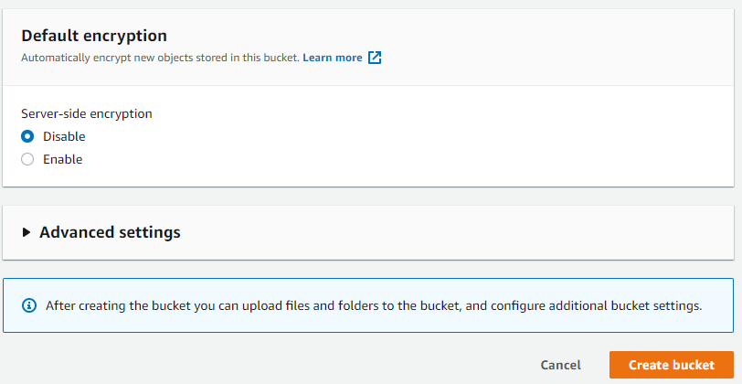

F.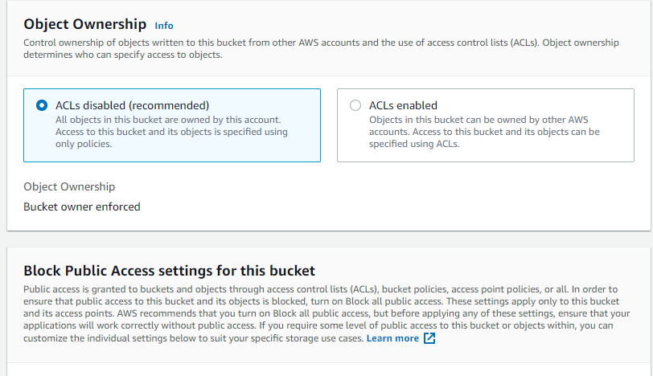

G.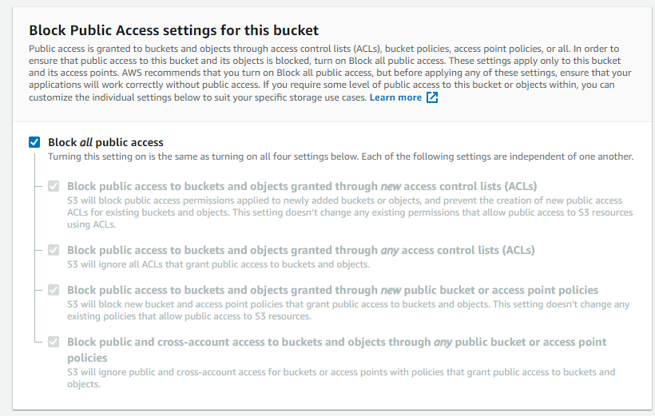

H.

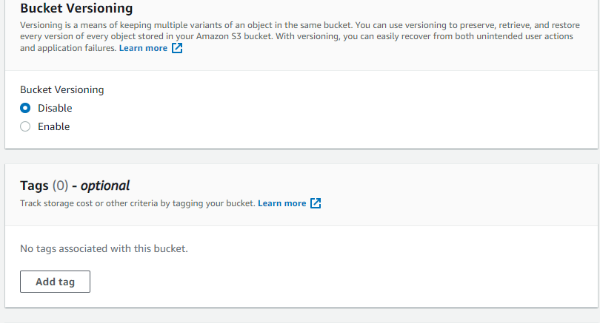

I.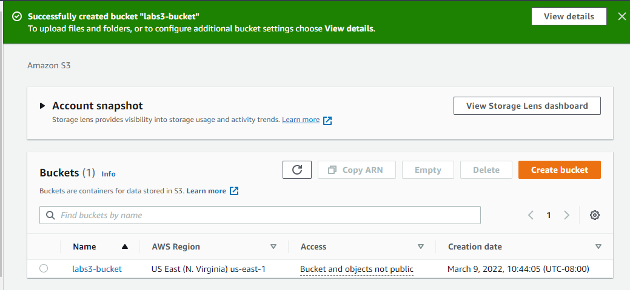

Perfect here we can see it my bucket is successfully done as name this bucket

‘labs3-bucket’

11. In this step we going to the deleting the bucket which we created

A.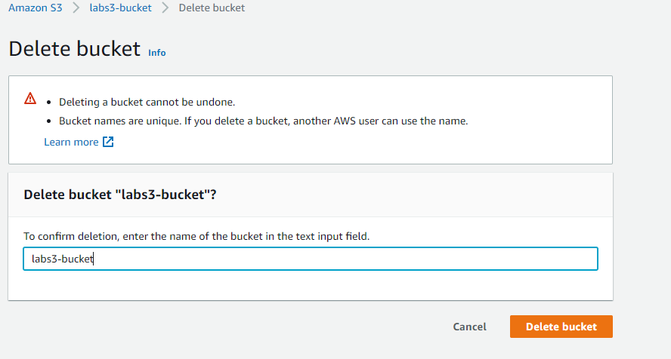

B.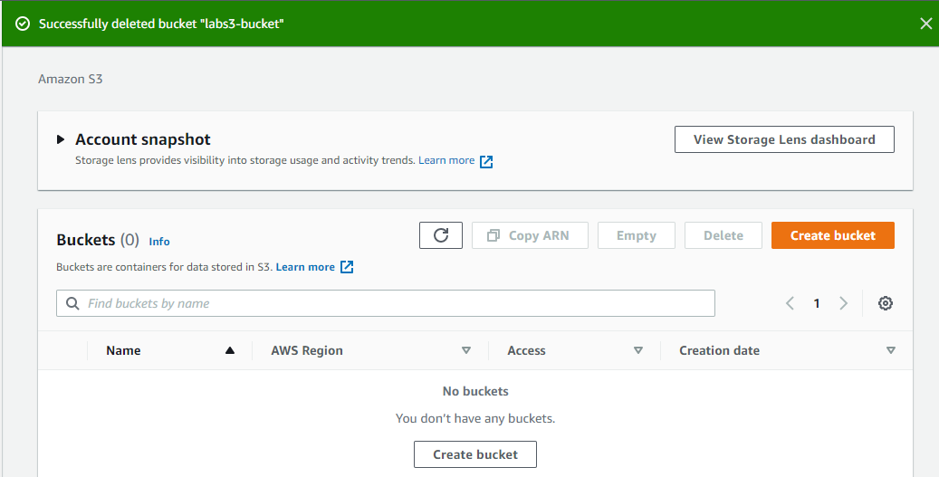

It is successfully deleted and

my lab is to create iam user, to give identity based policy to the user is successfully done